**WEEK 7 ASSIGNMENT BDWUP**

**RETRIEVE DATA FROM AN EXCEL FILE (CONNECT EXCEL FILE WITH DUMMY)**

**AIM:**

To retrieve data from a EXCEL file and click preview rows to verify the file is being read correctly.

**ALGORITHM:**

1.Start the process.

2.Create a Sales database using Excel.

3.Save the file in .xls format.

4.Open Pentaho Spoon tool for data integration.

5.Choose text input and text output for data retrieval.

6.Save the file.

7.Stop the process.

**OUTPUT:**

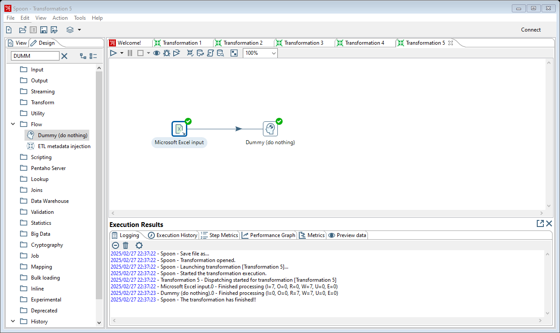

**Result :**

The above termination is executed successfully.